**New Project**

**Image 1**

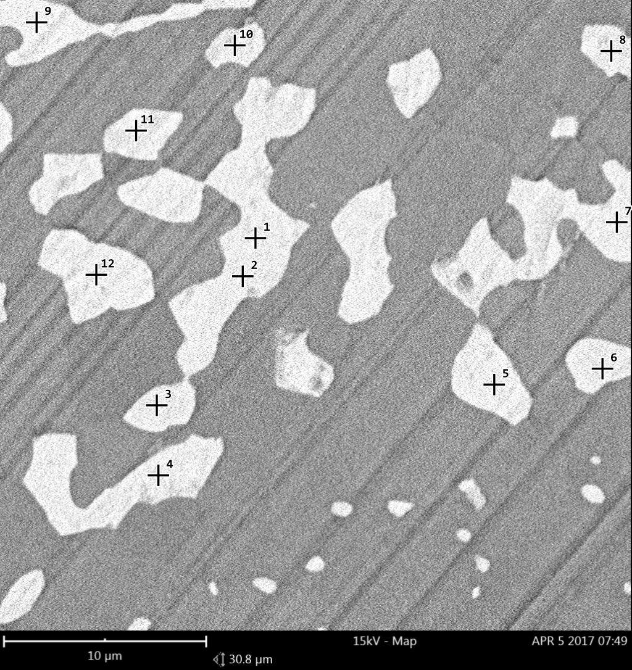

**1. spot**

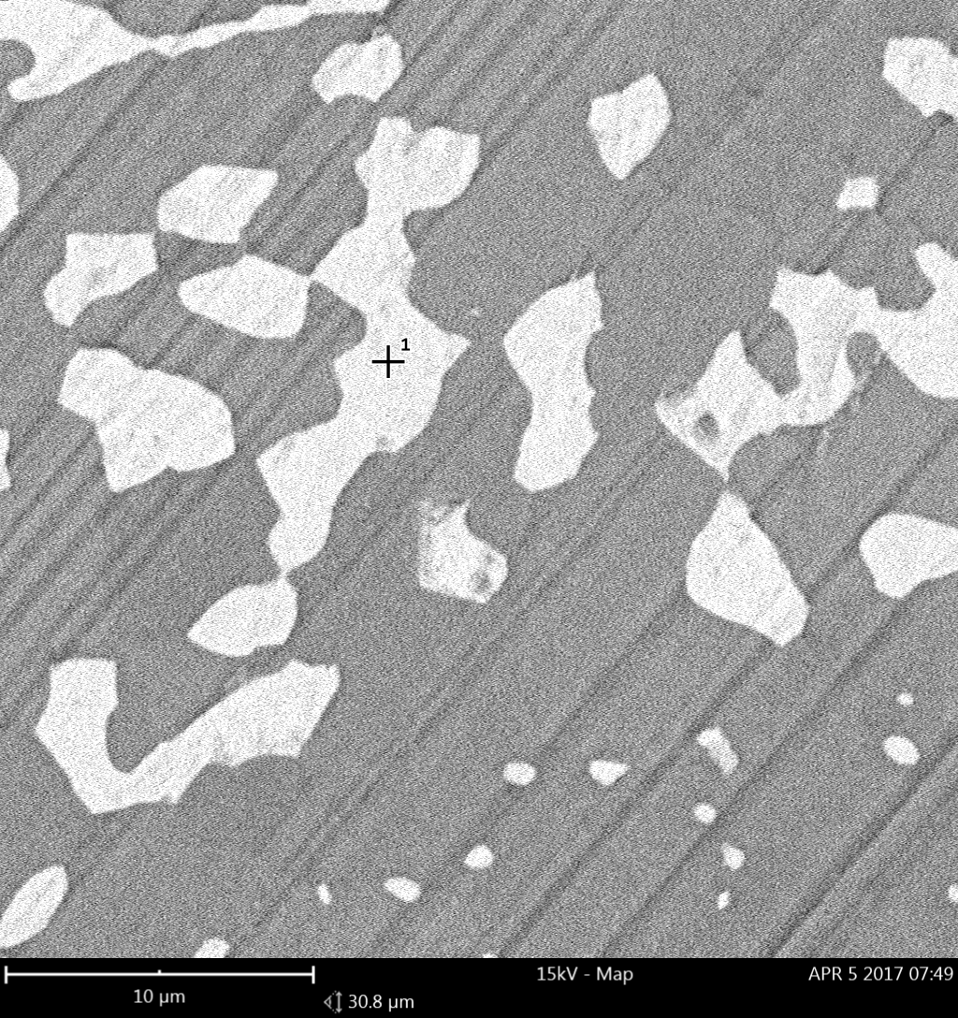

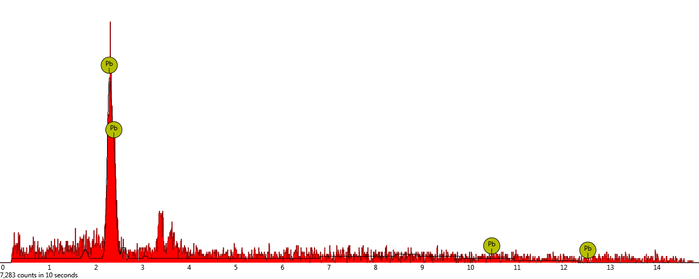

|  |  |  |  |  |  |
| --- | --- | --- | --- | --- | --- |
| **Element Number** | **Element Symbol** | **Element Name** | **Confidence** | **Concentration** | **Error** |
|  |  |  |  |  |  |

**2. spot**

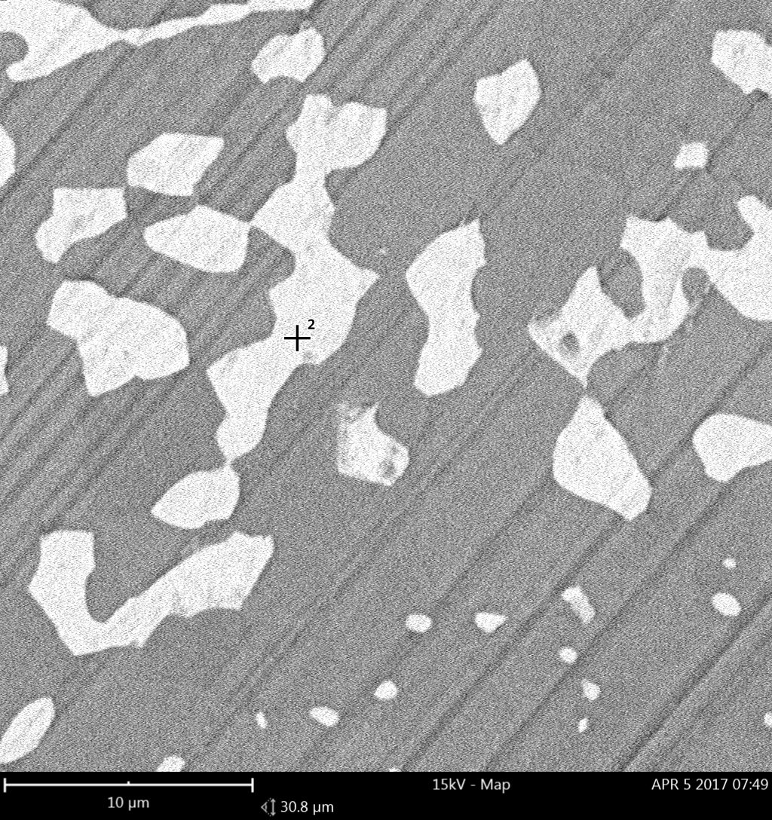

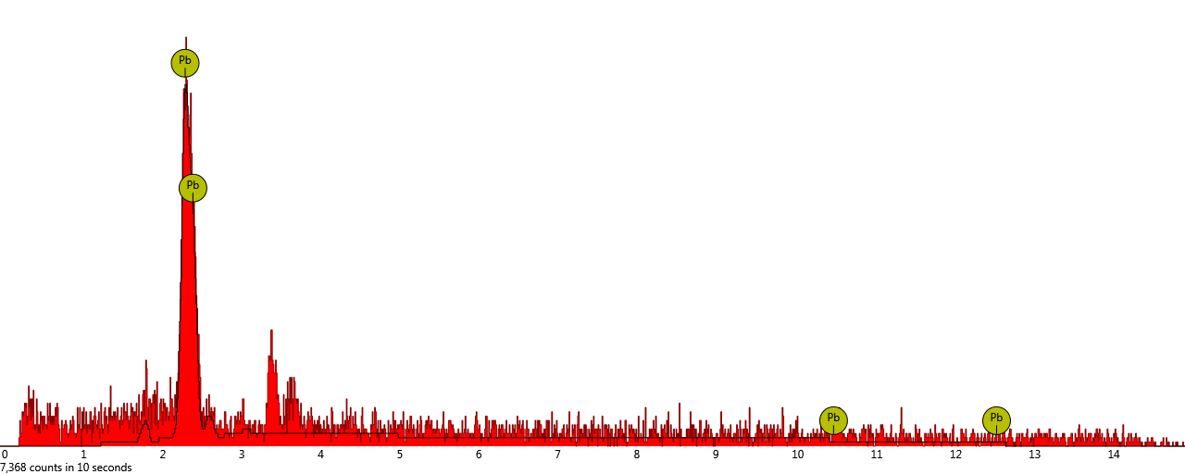

|  |  |  |  |  |  |
| --- | --- | --- | --- | --- | --- |
| **Element Number** | **Element Symbol** | **Element Name** | **Confidence** | **Concentration** | **Error** |
|  |  |  |  |  |  |

**3. spot**

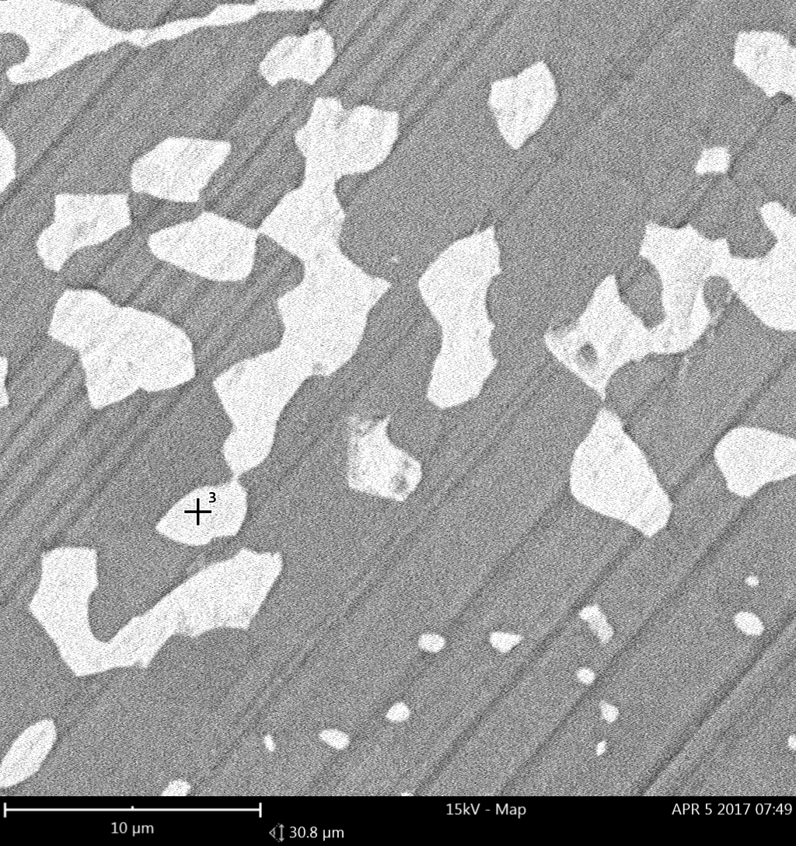

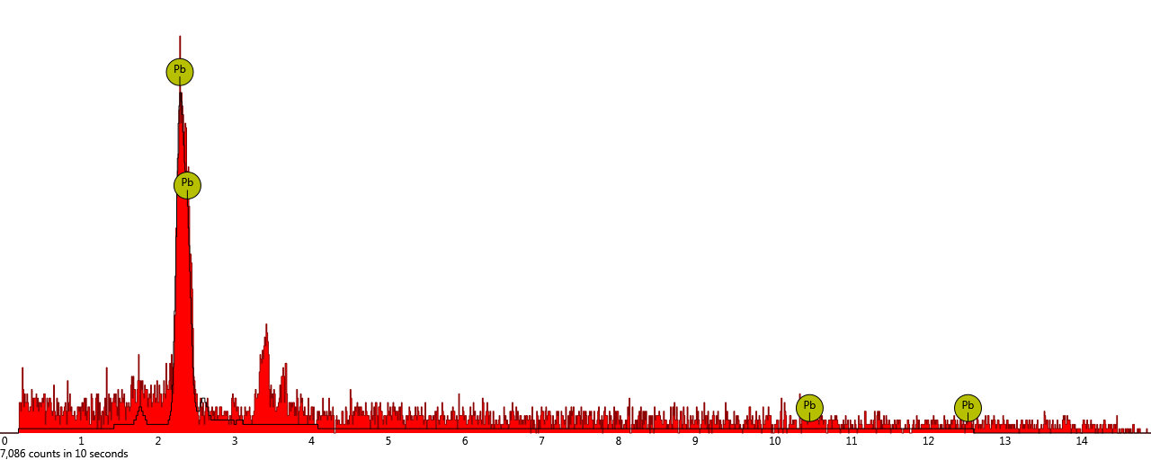

|  |  |  |  |  |  |
| --- | --- | --- | --- | --- | --- |
| **Element Number** | **Element Symbol** | **Element Name** | **Confidence** | **Concentration** | **Error** |
|  |  |  |  |  |  |

**4. spot**

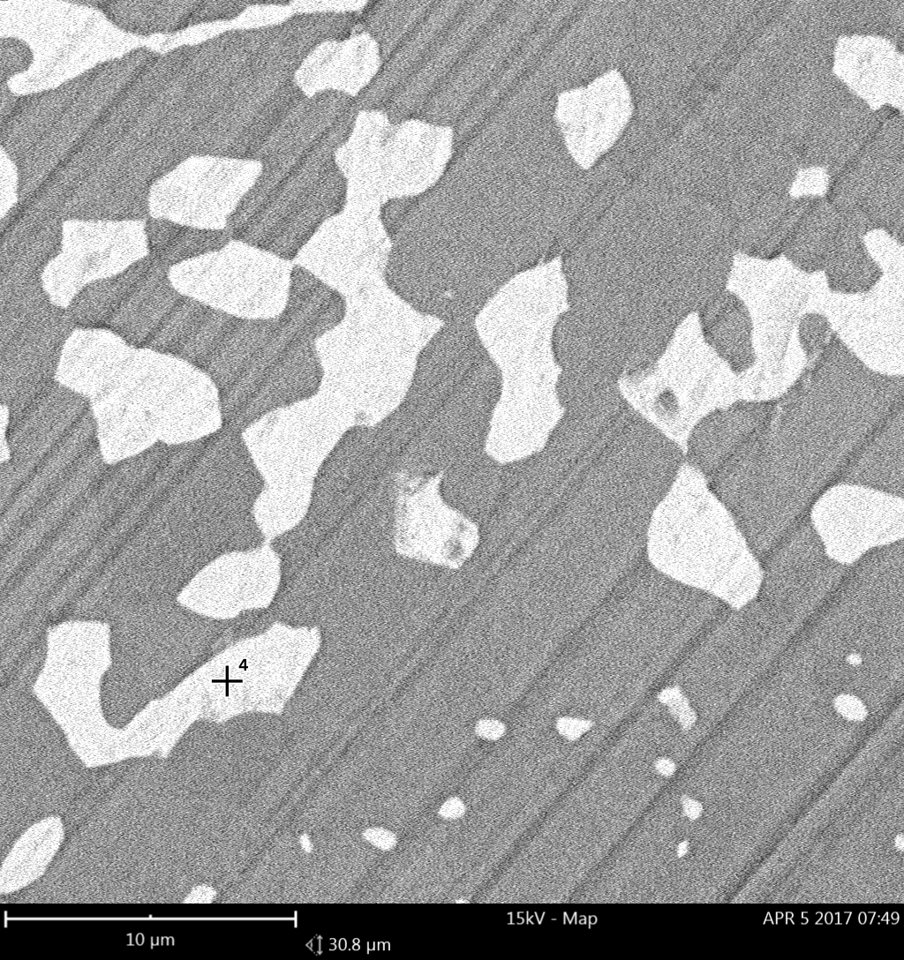

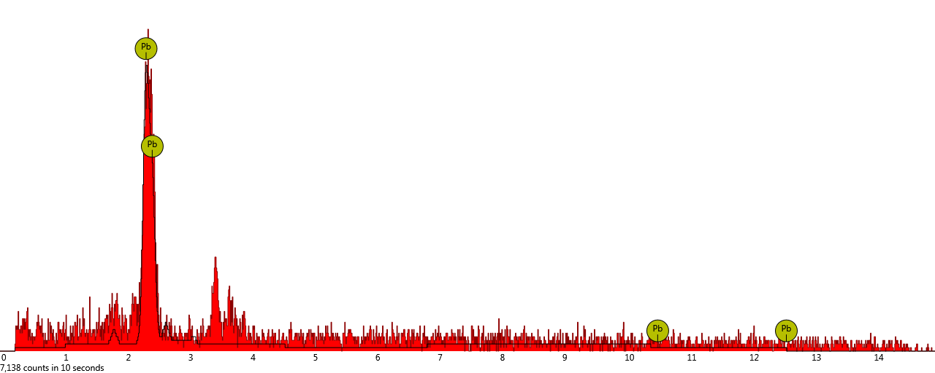

|  |  |  |  |  |  |
| --- | --- | --- | --- | --- | --- |
| **Element Number** | **Element Symbol** | **Element Name** | **Confidence** | **Concentration** | **Error** |
|  |  |  |  |  |  |

**5. spot**

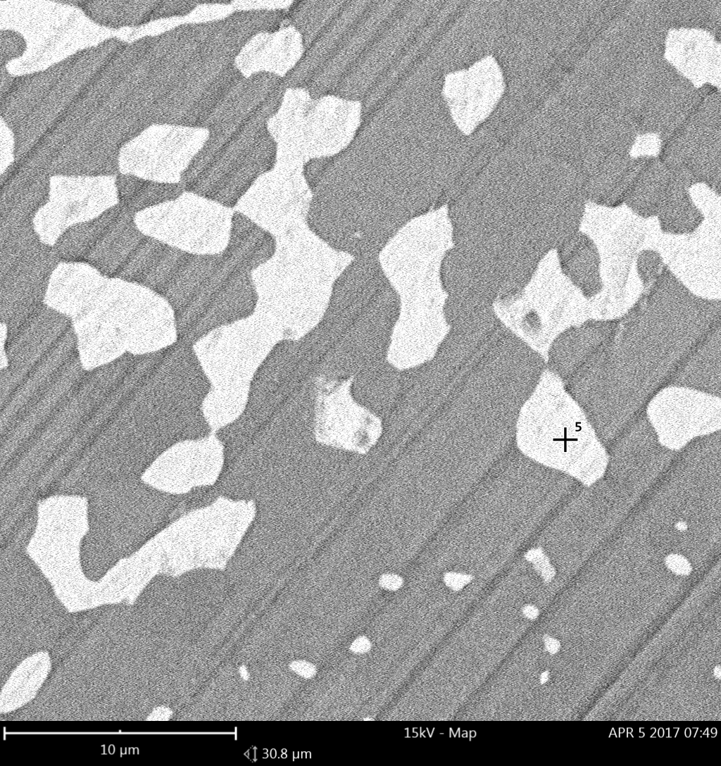

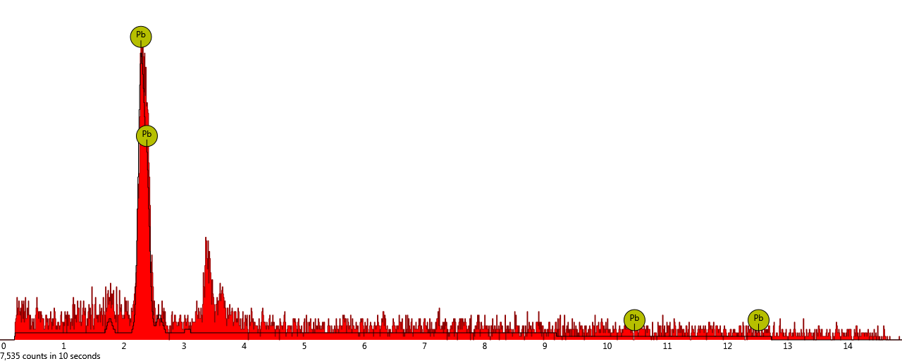

|  |  |  |  |  |  |
| --- | --- | --- | --- | --- | --- |
| **Element Number** | **Element Symbol** | **Element Name** | **Confidence** | **Concentration** | **Error** |
|  |  |  |  |  |  |

**6. spot**

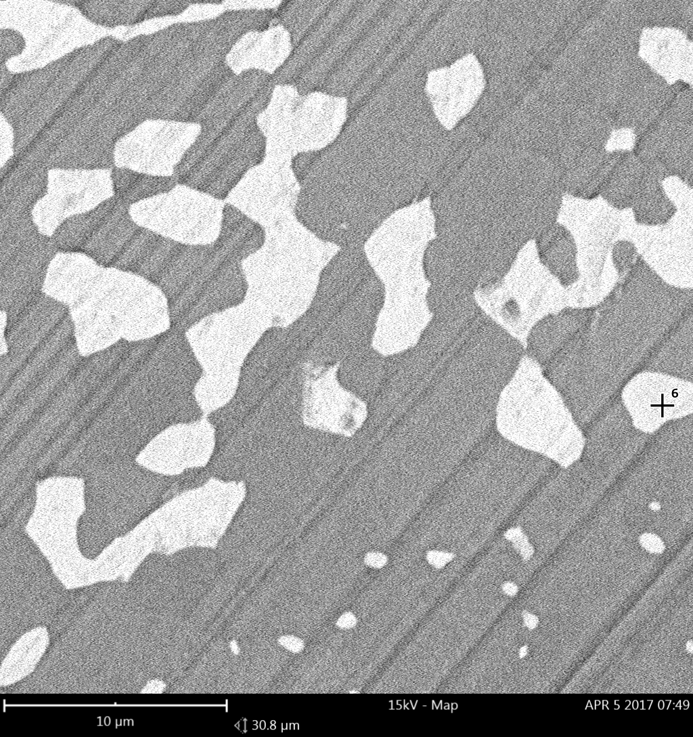

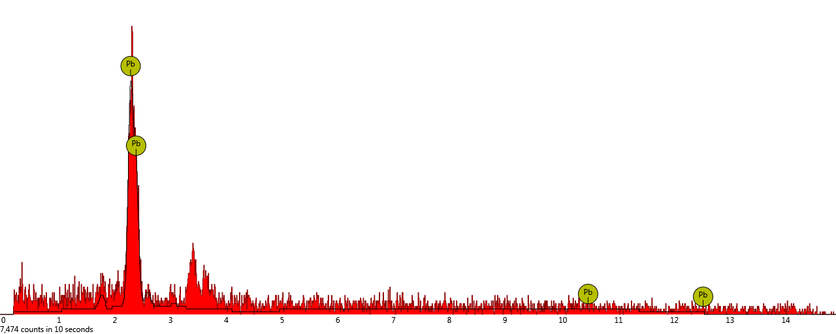

|  |  |  |  |  |  |
| --- | --- | --- | --- | --- | --- |
| **Element Number** | **Element Symbol** | **Element Name** | **Confidence** | **Concentration** | **Error** |
|  |  |  |  |  |  |

**7. spot**

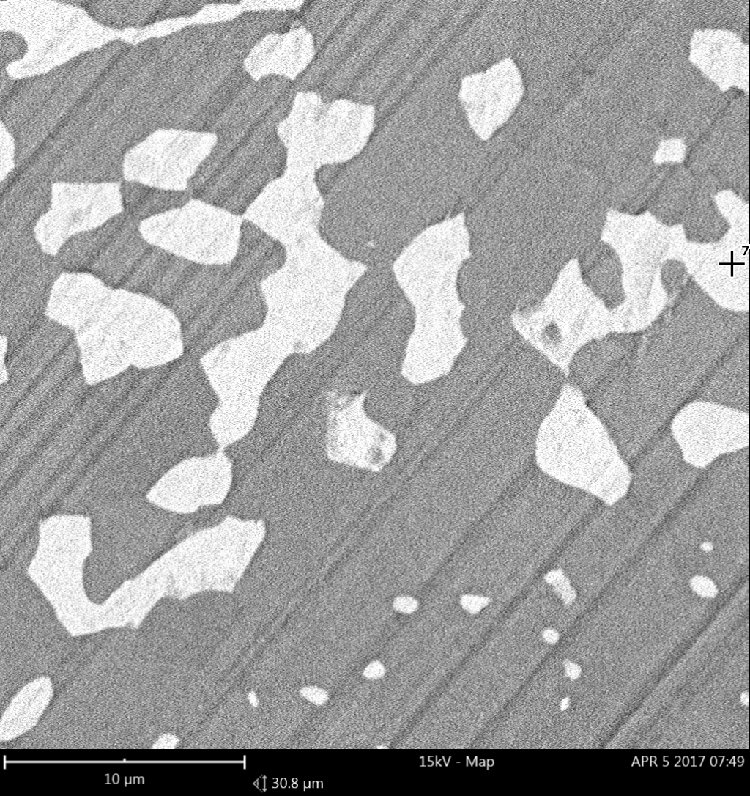

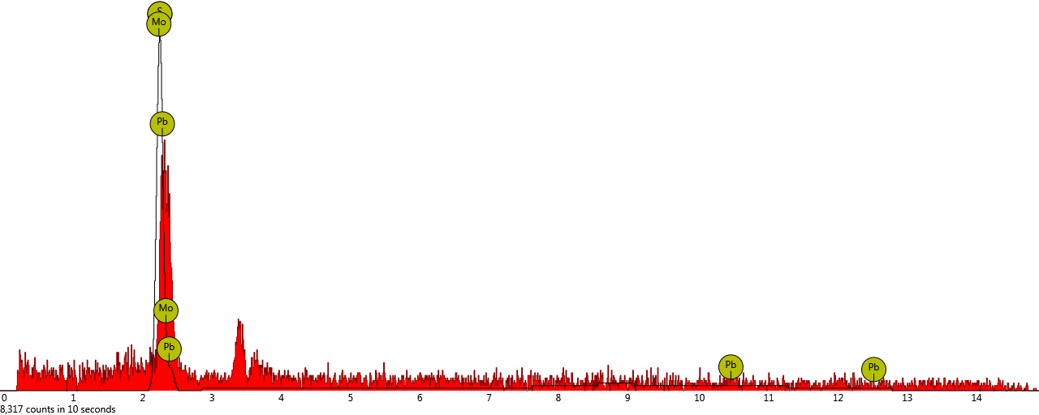

|  |  |  |  |  |  |
| --- | --- | --- | --- | --- | --- |
| **Element Number** | **Element Symbol** | **Element Name** | **Confidence** | **Concentration** | **Error** |
|  |  |  |  |  |  |
|  |  |  |  |  |  |
|  |  |  |  |  |  |

**8. spot**

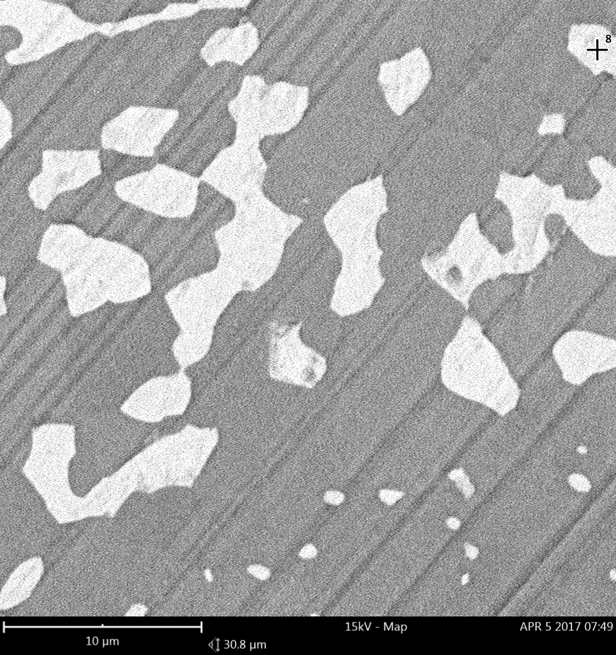

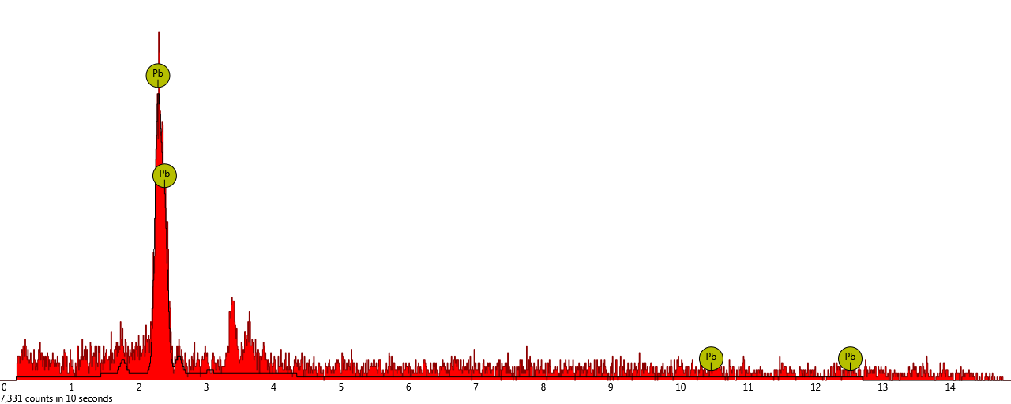

|  |  |  |  |  |  |
| --- | --- | --- | --- | --- | --- |
| **Element Number** | **Element Symbol** | **Element Name** | **Confidence** | **Concentration** | **Error** |
|  |  |  |  |  |  |

**9. spot**

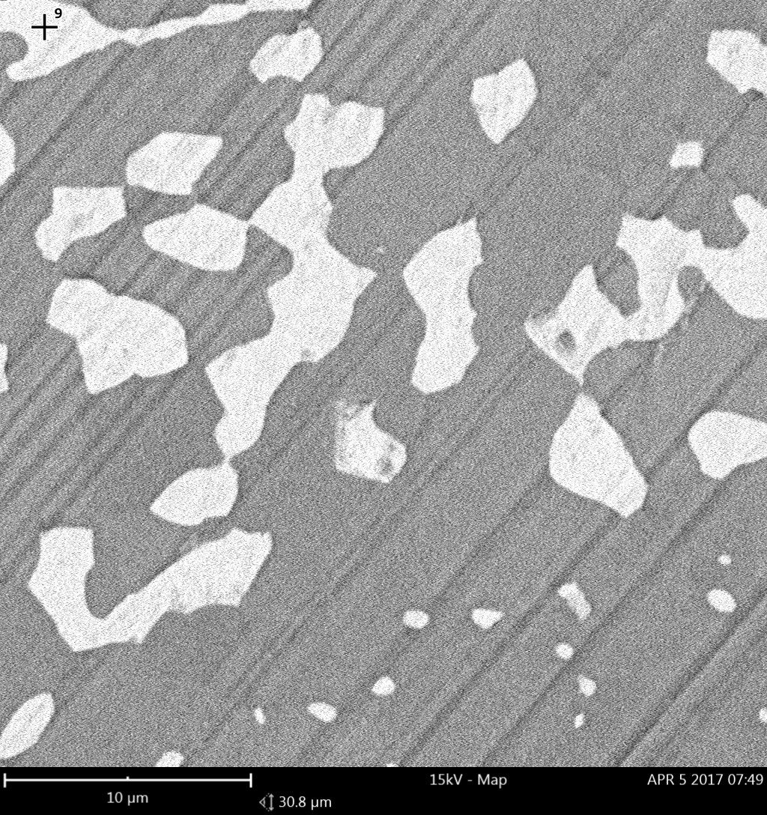

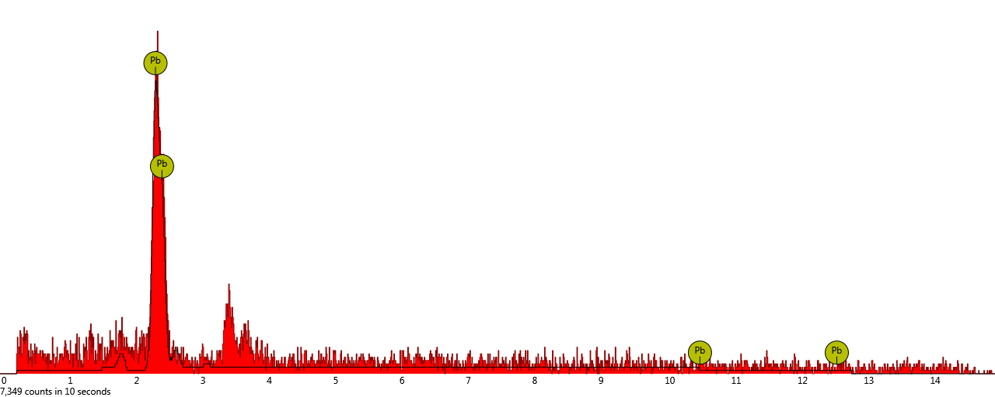

|  |  |  |  |  |  |
| --- | --- | --- | --- | --- | --- |
| **Element Number** | **Element Symbol** | **Element Name** | **Confidence** | **Concentration** | **Error** |
|  |  |  |  |  |  |

**10. spot**

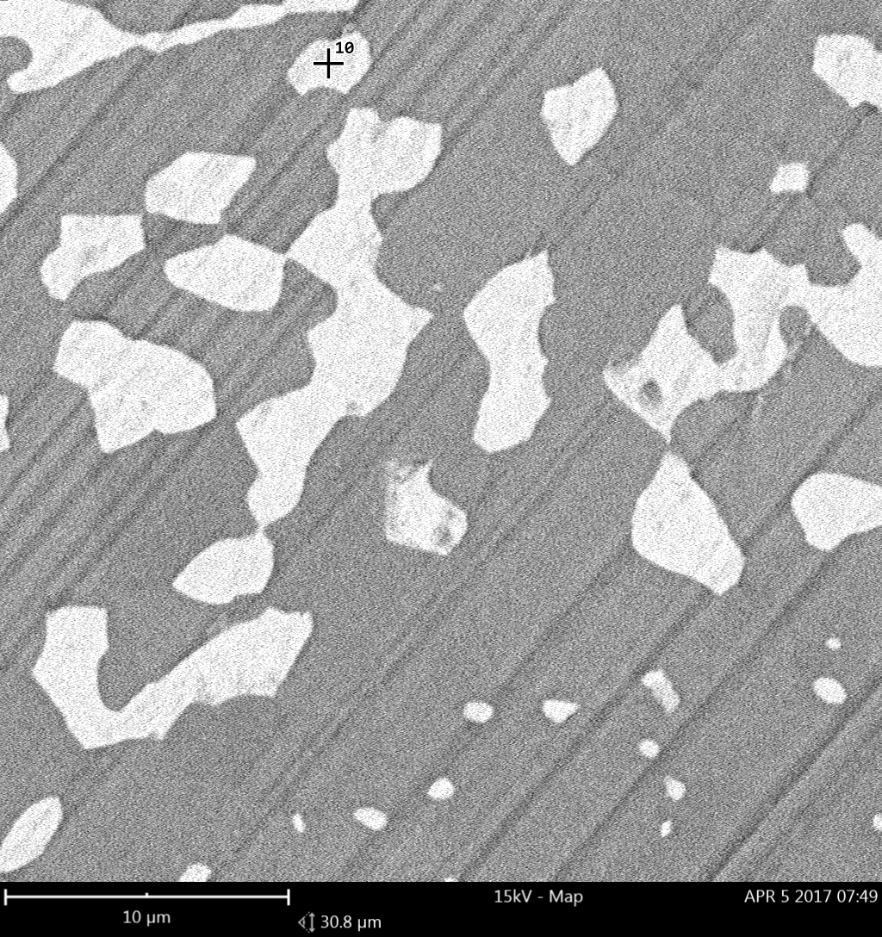

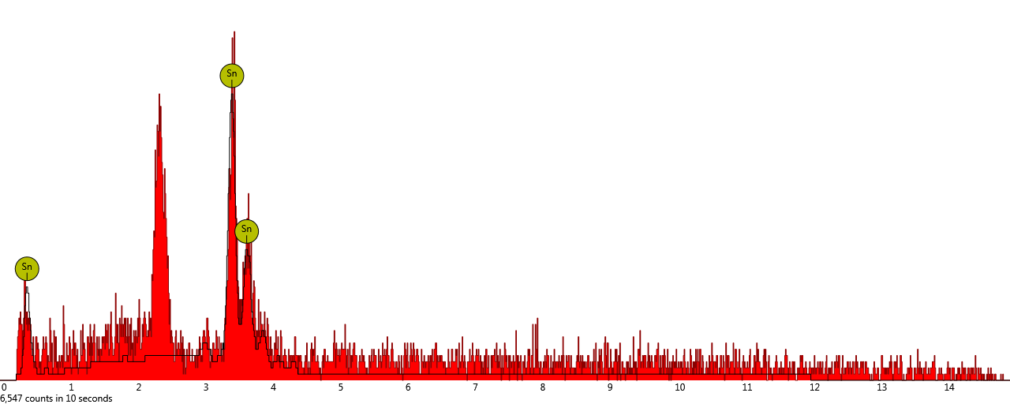

|  |  |  |  |  |  |
| --- | --- | --- | --- | --- | --- |
| **Element Number** | **Element Symbol** | **Element Name** | **Confidence** | **Concentration** | **Error** |
|  |  |  |  |  |  |

**11. spot**

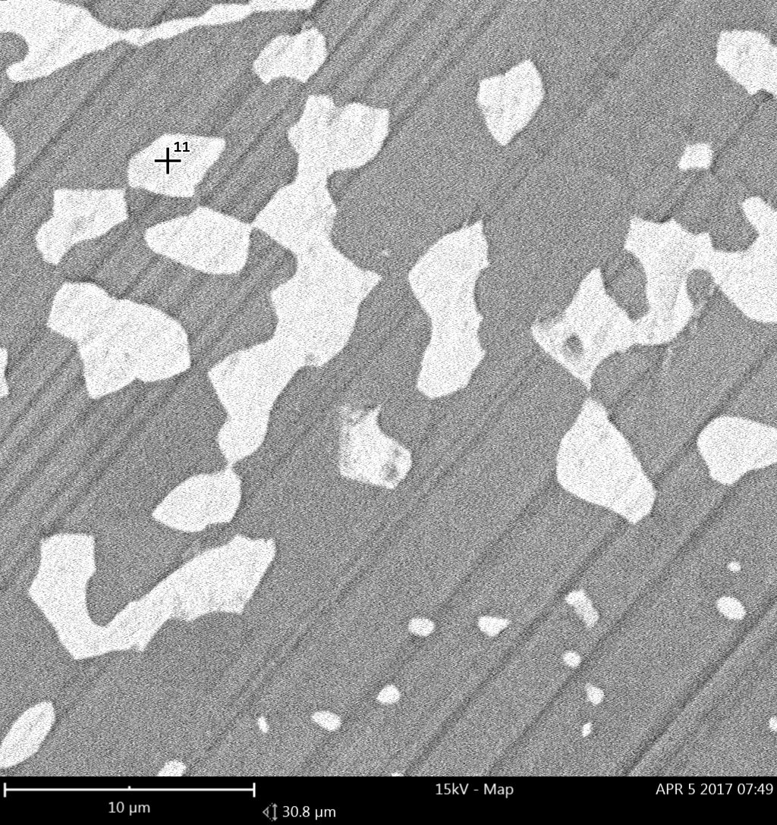

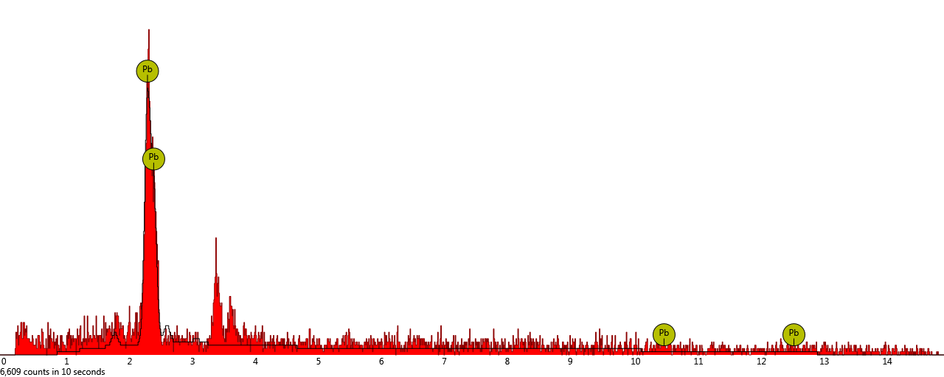

|  |  |  |  |  |  |
| --- | --- | --- | --- | --- | --- |
| **Element Number** | **Element Symbol** | **Element Name** | **Confidence** | **Concentration** | **Error** |
|  |  |  |  |  |  |

**12. spot**

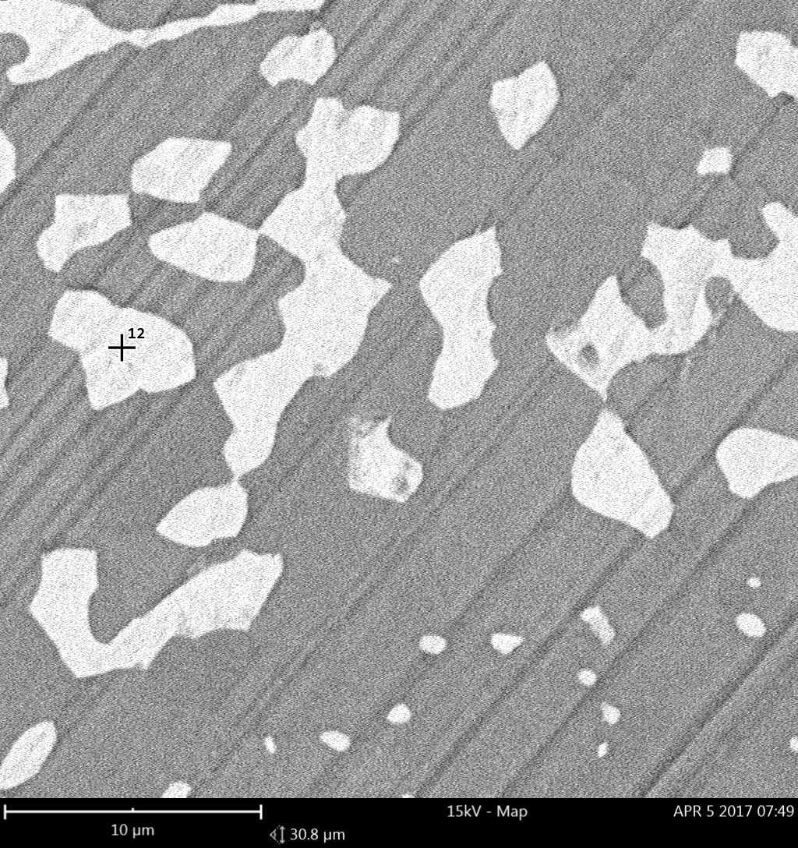

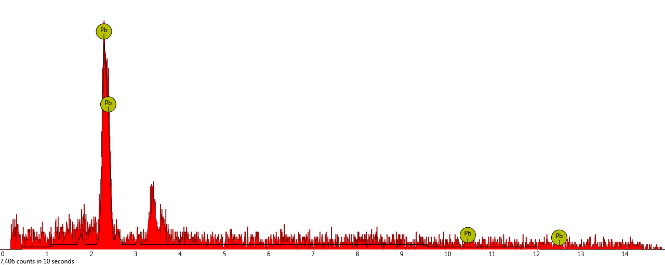

|  |  |  |  |  |  |
| --- | --- | --- | --- | --- | --- |
| **Element Number** | **Element Symbol** | **Element Name** | **Confidence** | **Concentration** | **Error** |
|  |  |  |  |  |  |